Introduction:

The Expectation-Maximization (EM) algorithm is a powerful iterative method used for estimating parameters in statistical models when dealing with incomplete data. One of the classic applications of the EM algorithm is in fitting Gaussian Mixture Models (GMMs). GMMs are probabilistic models that assume the data is generated from a mixture of several Gaussian distributions.

Gaussian Mixture Model (GMM): A Gaussian Mixture Model represents a probability distribution as a weighted sum of multiple Gaussian distributions. Mathematically, for a dataset with N data points, a GMM can be defined as:

$$p\left(x\right)=\sum_{k=1}^{K}{π_{k}}​N\left(x ∣ μ_{k}​,Σ_{k}\right)$$

where:

K is the number of Gaussian components.

πk  is the weight associated with the kth Gaussian component (0≤ πk ≤1 and $\sum_{k=1}^{K}{π_{k}}​=1$.

μk is the mean vector of the kth Gaussian component.

Σk is the covariance matrix of the kth Gaussian component.

N(x∣μk ,Σk ) is the probability density function of a multivariate Gaussian distribution.

EM Algorithm for GMM: The EM algorithm is used to estimate the parameters (πk , μk , and Σk ) of the GMM. It iterates between two main steps: the E-step (Expectation step) and the M-step (Maximization step).

Initialization:

Initialize the parameters of the GMM randomly or using some heuristics.

E-step:

Compute the posterior probabilities (responsibilities) of each data point belonging to each Gaussian component using the current parameter estimates.

These posterior probabilities are calculated using Bayes' theorem as 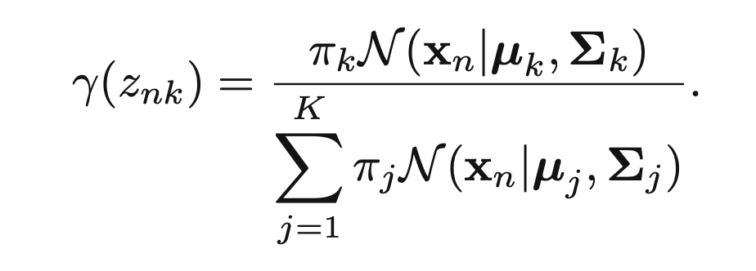

M-step:

Update the parameters of the GMM based on the posterior probabilities computed in the E-step.

Update the weights *πk*, means μk , and covariance matrices Σk  using the weighted data points as

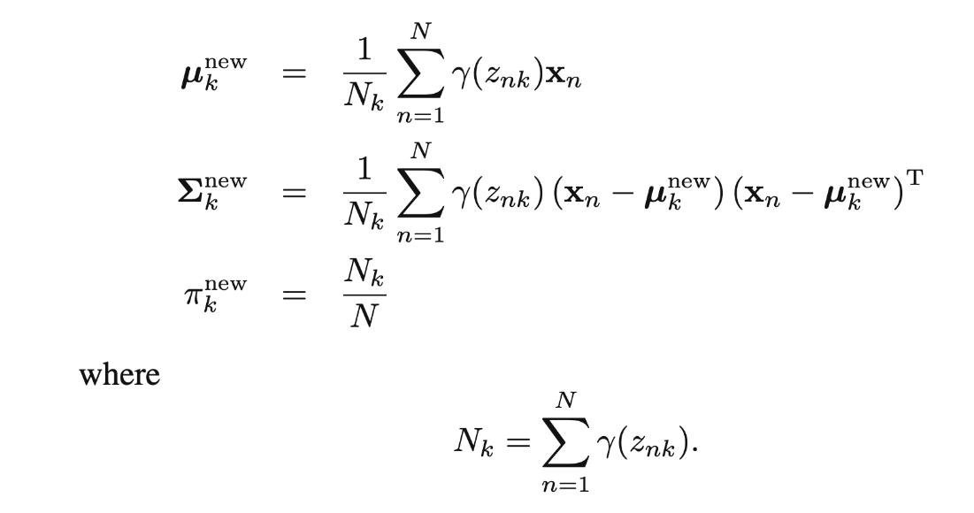

Convergence Check:

Repeat the E-step and M-step until convergence criteria are met. Common criteria include a maximum number of iterations, negligible changes in the parameters between iterations, or a threshold for the increase in the likelihood function.

Advantages of EM Algorithm for GMM:

Can handle incomplete or missing data effectively.

Allows for flexible modeling of complex data distributions.

Provides a probabilistic framework for clustering, allowing for uncertainty estimation.

Converges to a local maximum of the likelihood function.

Challenges:

Sensitive to initialization: Different initializations can lead to different solutions.

Convergence to local optima: The EM algorithm may converge to a local maximum of the likelihood function rather than the global maximum.

Computationally expensive for large datasets and high-dimensional data due to the iterative nature of the algorithm.

Applications:

* Pattern recognition and classification.
* Image segmentation.
* Anomaly detection.
* Natural language processing.

Conclusion: The EM algorithm provides an effective means of estimating parameters for Gaussian Mixture Models, allowing for flexible modelling of complex data distributions. Despite its challenges, it remains a widely used method in various fields for its ability to handle incomplete data and provide probabilistic clustering solutions. However, careful consideration of initialization and convergence criteria is essential for obtaining meaningful results.

**Code Explanation:**

First we create a fake dataset.

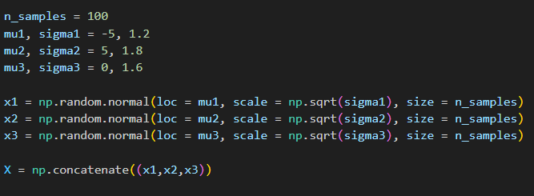

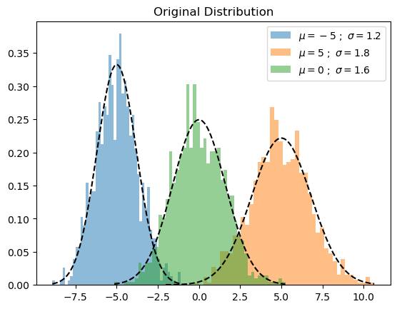

Gaussian Mixture Model Code:

Step 1:

**Initialize mean, covariance, and weights:**

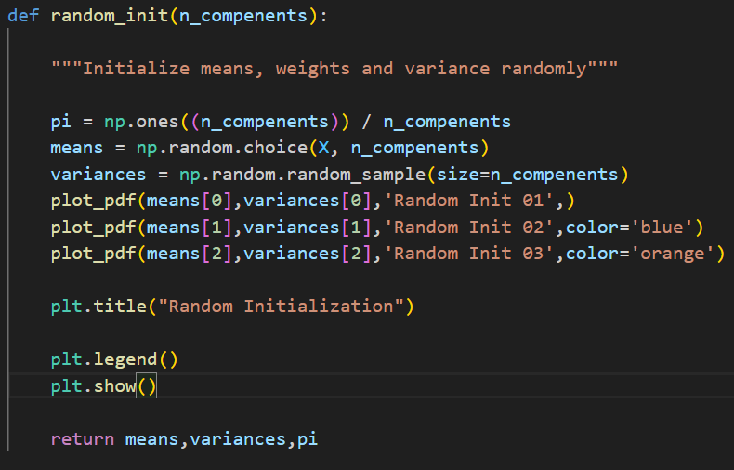

This function initializes the parameters for a Gaussian Mixture Model (GMM) randomly:

* Weights (pi): It sets the weights for each component to be equal.
* Means and Variances: It randomly selects means and variances for each component.
* Visualization: It plots the initial Gaussian distributions for visualization.

Step 2:

**Expectation Step (E step)**

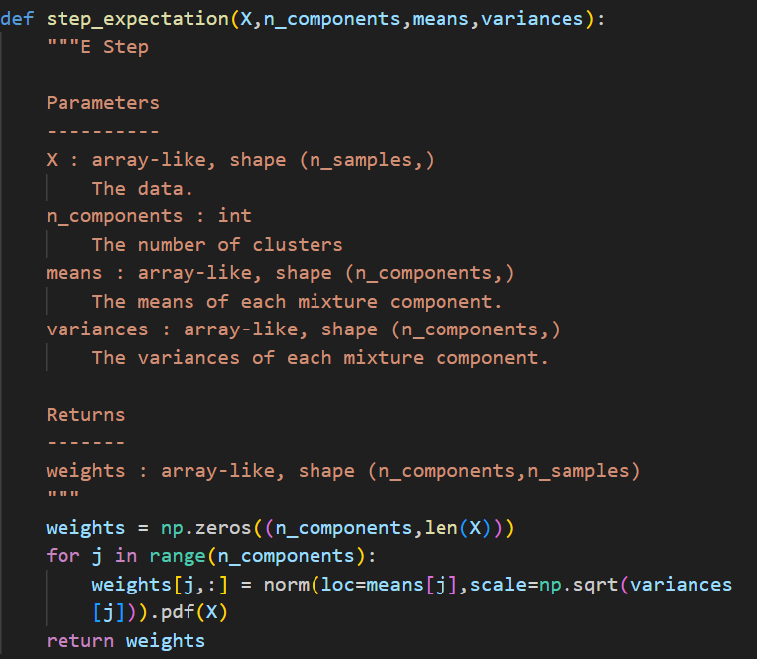

* **Purpose**: Calculates the likelihood of each data point belonging to each Gaussian component in a GMM.
* **Inputs:**
  + X: Data points.
  + n_components: Number of Gaussian components.
  + means: Means of Gaussian components.
  + variances: Variances of Gaussian components.
* **Output:**
  + weights: Matrix storing likelihood values.
* **Initialization:** Creates an empty matrix weights.
* **Loop Over Components:**
  + For each component, calculates likelihoods using Gaussian distributions with respective means and variances.
* **Storing Likelihoods:**
  + Stores likelihood values in weights matrix.
* **Return:**
  + Returns the matrix weights.

Step 3:

**Maximization Step (M step)**

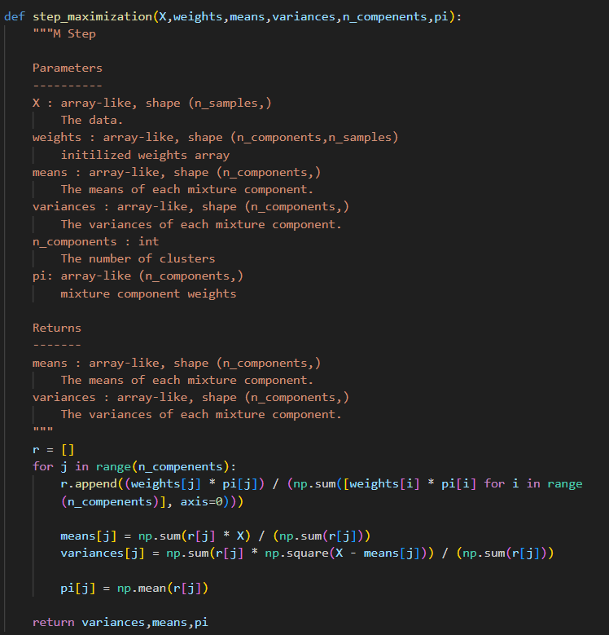

* **Purpose**:
  + Updates the parameters (means, variances, and mixture component weights) of a Gaussian Mixture Model (GMM) based on the current data assignments.
* **Inputs**:
  + **X**: Data points.
  + **weights**: Probabilities of data points belonging to each component.
  + **means**: Current means of Gaussian components.
  + **variances**: Current variances of Gaussian components.
  + **n_components**: Number of Gaussian components.
  + **pi**: Current mixture component weights.
* **Outputs**:
  + Updated **means**, **variances**, and **pi**.
* **Responsibilities Calculation**:
  + Calculates responsibilities for each data point based on the current weights and mixture component weights.
* **Updating Means and Variances**:
  + Updates means and variances based on calculated responsibilities and data points.
* **Updating Mixture Component Weights**:
  + Updates mixture component weights based on calculated responsibilities.
* **Return**:
  + Returns the updated **means**, **variances**, and **pi**.

**Gaussian mixture model function:**

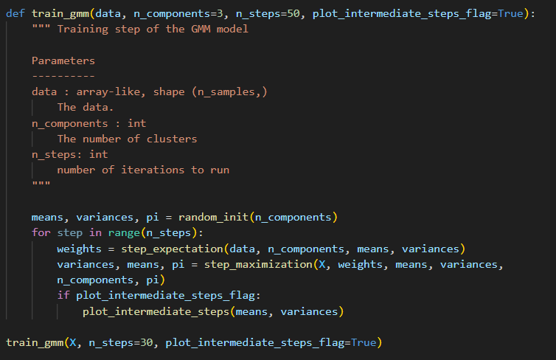

* **Purpose**:
  + Trains a Gaussian Mixture Model (GMM) using the Expectation-Maximization (EM) algorithm.
* **Inputs**:
  + **data**: Input data points.
  + **n_components**: Number of Gaussian components.
  + **n_steps**: Number of iterations.
  + **plot_intermediate_steps_flag**: Flag to plot intermediate steps.
* **Initialization**:
  + Initializes model parameters (**means**, **variances**, and **pi**) using **random_init**.
* **Iterations**:
  + Iterates **n_steps** times.
* **E-step**:
  + Computes likelihood of data points belonging to each component using **step_expectation**.
* **M-step**:
  + Updates model parameters using **step_maximization**.
* **Plotting**:
  + Optionally plots intermediate steps if **plot_intermediate_steps_flag** is **True**.
* **Output**:
  + No explicit return; model parameters are updated in-place.

**SOME IMPORTANT GRAPHS OF CODE**

